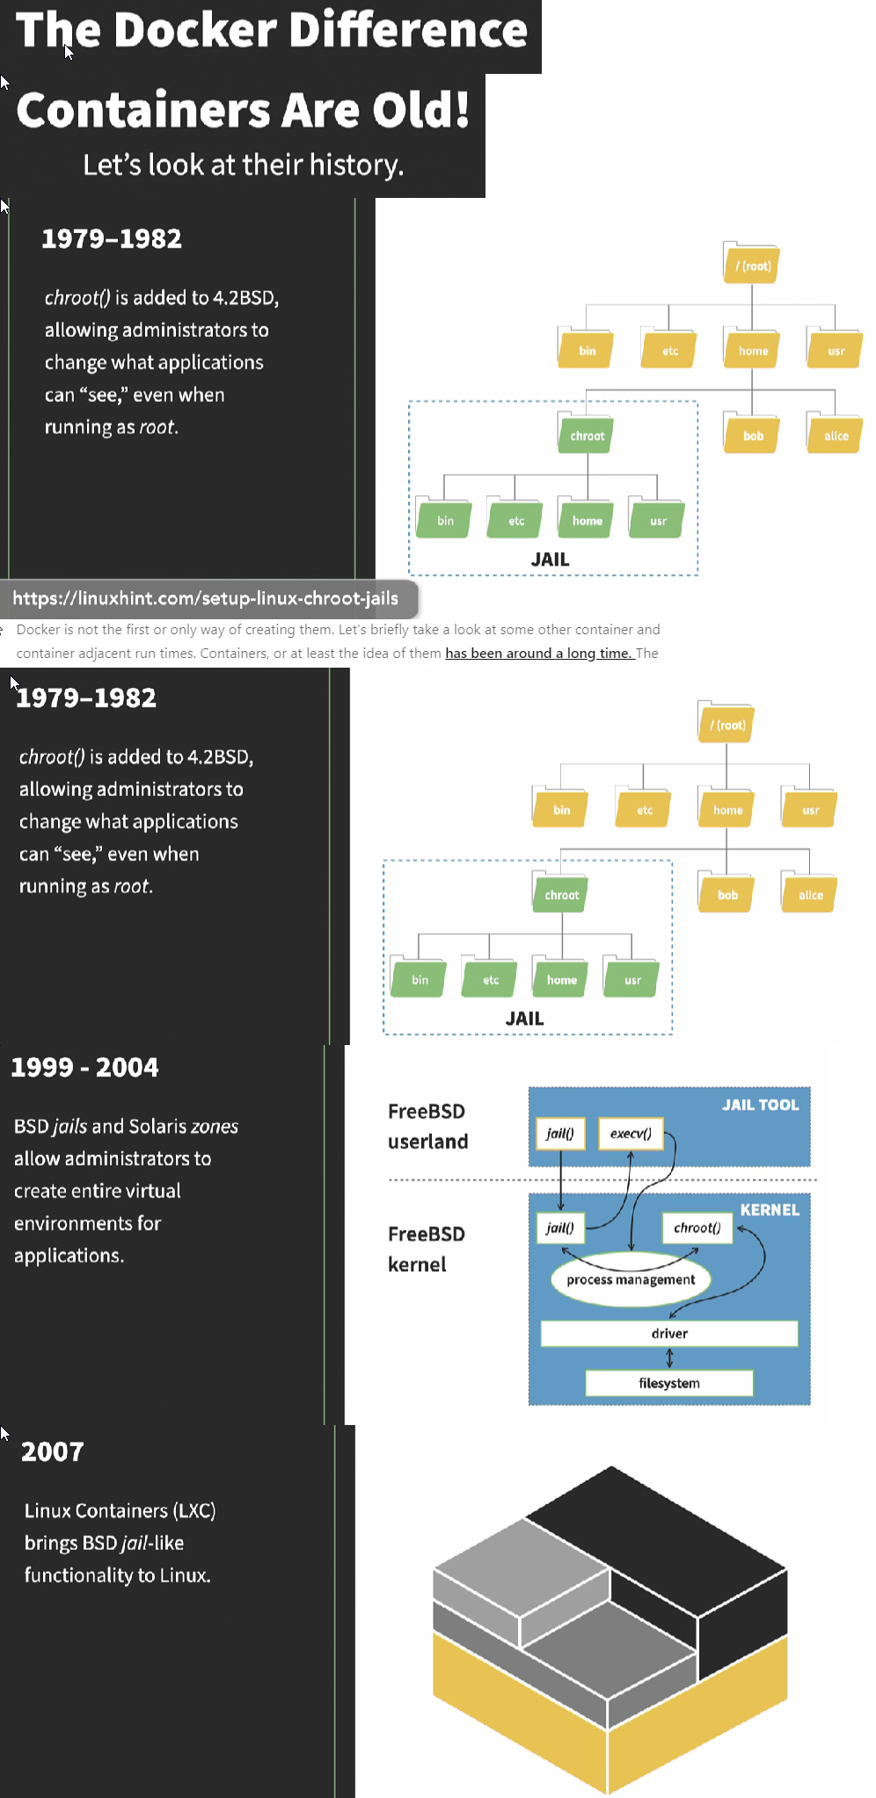

docker ps

docker run hello-world

On powershell.

On Linux:

sudo apt install curl

curl -o /tmp/get-docker.sh https://get.docker.com

sh /tmp/get-docker.sh

sudo docker run hello-world

sudo usermod -aG docker $USER

docker container create --help

docker container create hello-world:linux # does not start containers

docker ps

docker ps --all #shows all containers docker knows about

docker container start 6eff6725379ghyt54 #start the docker container

docker ps --all #likely a problem

docker logs 6ef #first 3 characters

docker container start --attach cb2 #attach output

docker run hello-world:linux #alternative

Create Docker Container:

docker build --help

docker build -t our-first-image

docker run our-first-image

vim server.Dockerfile

docker build --file server.Dockerfile --tag our-server #intermediate images to final image

docker run our-server

To kill:

New Terminal:

docker ps #copy first 3 letters of id

docker kill d90d

Otherwise,

docker run -d our-server

docker ps #verify that the container is running

Can be used to run additional commands using docker exec, helpful while troubleshooting problems, or testing images created by application’s docker file.

docker exec d90d date

docker ps -a

docker stop d90d #stop container